FINAL VERSION

Introduction

The Emotion Works Bronze School Award overlaps with the Getting Started with Emotion Works training and teaching modules and the subsequent roll-out of a 1-cog-at-a-time teaching Programme.

Schools who have been using Emotion Works for some time will have covered a lot of this work in the past using older training approaches and website material. Those who joined in 2020 /early 2021 would have covered Bronze Award content using the Recovery Programme website, and those who have followed the training and teaching content provided in our Literacy Programme Blocks 1 & 2 (since August 2021) will have also have lots to draw on to complete a Bronze Application.

From April 2022, the following guides for school leads and teachers provide a perfect framework to help you easily work towards a Bronze School Award

- The Getting Started Implementation Guide checklist for school leads
- The Getting Started Training & Teaching checklist for teachers

Completing & Submitting your Application

- For the Bronze Award you should provide all evidence within this Word Document.
- The table rows will expand to accommodate your text and other evidence.
- It’s helpful for us to have your supporting statements highlighted in yellow as in the example provided here
- We are trusting school leads to vouch for the first stage of Emotion Works implementation across the school by providing brief, summary statements for the different criteria, along with some photographic or video evidence.
- Photographs / images should be cropped / resized to less than 1mb each before adding.
- If you would like to include a video file – please provide a weblink rather than adding the file itself.
- Please save a copy of your application using the title EWBronze_school name.doc
- Email your application to practice@emotionworks.org.uk, marked with the same title
- Your email and application will be acknowledged within a few days from our Practice Support team, who will flag up any obvious omissions or changes required.
- Your application will then be passed on to Vicki Renton for assessment who will highlight any requests or next steps feedback in blue and return to you within 2 weeks of receiving your application (not including school holidays).

INTRODUCTORY SECTION

SCHOOL NAME |  |  | here
LOCAL AUTHORITY |  |  | here
WHEN DID YOU FIRST START USING EW IN YOUR SCHOOL? |  |  |  |  |  | here
WHAT KIND OF EW PACKAGE DOES YOUR SCHOOL YOU CURRENTLY HAVE? – please highlight below
6-month Trial | Full 1 year Basic |  |  | Full 2-year Premium |  |  | Full 3-year Platinum |  | Annual renewal
WHAT KIND OF TRAINING IN EW HAVE YOUR STAFF EXPERIENCED? – please highlight below
Inservice whole staff training pre-Covid |  | 1 or 2 staff attended open training pre-covid and cascaded |  |  | Online Recovery Programme Training  Aug 2020 - June 21 |  |  | Online Training since August 2021: ‘Getting Started’ & Literacy Programme
OTHER TRAINING APPROACH
Please provide information

DO YOU HAVE A NURSERY? | here | DO YOU HAVE ANY NURTURE OR ASN CLASSES?  here
HOW MANY PRIMARY 1, 2, 2/3 CLASSES | here
HOW MANY PRIMARY 3/4, 3, 4, 4/5 CLASSES | here
HOW MANY PRIMARY 5/6, 6, 7 CLASSES | here

EMOTION WORKS SCHOOL LEAD 1 |  | SCHOOL LEAD 2 / ACCOUNT MANAGER*
Name | here | Name | here
Job title / role | here | Job title / role | here
email | here | email | here
* If you don’t already have a second school lead, please allocate a second person on your staff team who can manage your school website accounts & memberships

EVIDENCE SECTION

- EW SCHOOL / STAFF MEMBERSHIP & WEBSITE MANAGEMENT
Both school lead/s know how to allocate & manage the website memberships or ‘seats’ for our staff team.
We have a process in place to keep our EW school account up to date by removing or allocating new ‘seats’ when staff leave or join our team.
Supporting Statement
here
We have recently checked that all teachers (and SLT/support staff if required) have a website membership set up with their personal email addresses and everyone has confirmed they can access the members area of the website and know where the ‘Getting Started’ content is.
Supporting Statement
here

- STAFF DEVELOPMENT
GETTING STARTED / 1-COG-AT-A-TIME TRAINING

Class teachers have worked through the Getting Started training modules on the website as summarised in the Getting Started with Emotion Works Training & Teaching Checklist.

Or, for longer term EW members –

Class Teachers have been Introduced to Emotion Works and the 1-cog-at-a-time approach via Emotion Works face-to-face Introductory training in the past / the #EWrecovery Programme website / the older website training pages / from colleagues and practice sharing events / or other ways.
Teachers now have a copy of the Getting Started with Emotion Works Training & Teaching Checklist, and are aware of new training, resources & website support available to them.

Supporting Statement
here
GETTING STARTED / 1-COG-AT-A-TIME TEACHING

Class teachers have worked through the Getting Started teaching modules and delivered learning activities as summarised in the Getting Started with Emotion Works Training & Teaching Checklist.

Or, for longer term EW members –

Class Teachers have delivered the 1-cog-at-a-time approach using ideas and resources shared at previous face-to-face training / the #EWrecovery Programme teaching content / older website resources & ideas / other sources.
Teachers now have a copy of the Getting Started with Emotion Works Training & Teaching Checklist, so they are aware of new teaching ideas, resources & practice support available to them.

Supporting Statement
here
TEACHER FEEDBACK

Teaching Staff feel their experience of Emotion Works to date has helped them to deliver emotional learning experiences and support their pupils’ wellbeing. There is increased confidence in using the Cog-curriculum and positivity about continuing to use Emotion Works in our school
As evidenced by before & after ratings on the Teacher Competencies Tool, general CPD feedback or another method.

Supporting Statement with information about your method of staff assessment / feedback
here

- SCHOOL ENVIRONMENT
STAFFROOM

- We have a 7-cog model or ‘Model in Mind’ Staffroom Poster on display in our main staffroom / meeting room. This supports the use of shared language using the cogs for staff discussions about emotional incidents in school and for Emotion Works collegiate planning.
If you don’t have a hard copy of the Cog Model Staffroom Poster (with dialogue tool on the back), you can print one out here… https://www.emotionworks.org.uk/resources/model-in-mind-poster/
- We have the Practice Support QR poster on display in the staffroom or other meeting room. https://www.emotionworks.org.uk/resources/practice-support-qr-poster/
1. Supporting Statement / Photo  here | 2. Supporting Statement / Photo  here
CLASSROOMS

Each class has a dedicated reference or learning display featuring cog language/symbols or cog visuals matched to the EW level they are working at.
BRONZE CLASS CHALLENGE: School Leads check in all classes, 1 x photo required from each stage
Supporting Statement
here
Photo (Upper Primary) featuring 7 Cog Model  State which classroom here | Photo (Middle Primary) featuring 6 Cog Model  State which classroom here
Photo (Lower Primary) featuring 5 Cog Model  State which classroom here | Photo (Nursery) featuring cog language & symbols  State area / context here
COMMUNAL AREA / CENTRAL DISPLAY

There is at least one central / communal area in school that can be used as an EW reference point beyond the classroom (eg. in the assembly hall, playground, school library, a corridor etc.)
BRONZE SCHOOL CHALLENGE: Photo series or short video clip required including an account of where the resource is located and how it’s used.
Supporting Statement
here
Video link (url) optional
Photos | Photos

- IMPACT ON LEARNING
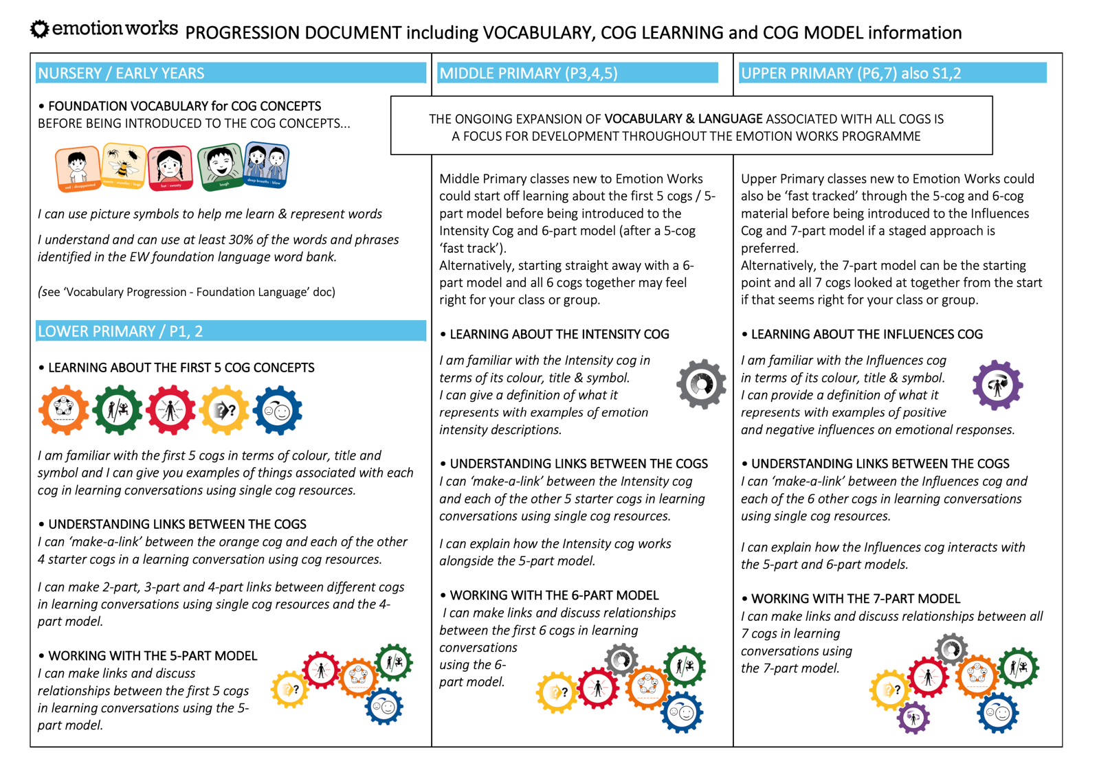
Given the EW learning goals for the Nursery / Lower Primary / Middle Primary / Upper Primary Stages summarised in the 2022 Progression Document, please rate how well you feel pupils in the following year groups are progressing with their learning at this point in their Emotion Works learning journey.
Please highlight the number/ fill the cell | No Progress | Limited progress | Satisfactory Progress | Good Progress | Excellent Progress
Nursery pupils age 3+ | 0 | 1 | 2 | 3 | 4
Nursery pupils age 4+ | 0 | 1 | 2 | 3 | 4
P1 pupils | 0 | 1 | 2 | 3 | 4
P2 pupils | 0 | 1 | 2 | 3 | 4
P3 pupils | 0 | 1 | 2 | 3 | 4
P4 pupils | 0 | 1 | 2 | 3 | 4
P5 pupils | 0 | 1 | 2 | 3 | 4
P6 pupils | 0 | 1 | 2 | 3 | 4
P7 pupils | 0 | 1 | 2 | 3 | 4
If you have pupils with identified Additional Support Needs (including Nurture, ASD, Learning Disabilities, Communication Needs etc.), please rate their Emotion Works progress relative to their general level of learning.
ASN pupils working at CfE 2nd level | 0 | 1 | 2 | 3 | 4
ASN pupils working at CfE 1st level | 0 | 1 | 2 | 3 | 4
ASN pupils working at CfE Early level | 0 | 1 | 2 | 3 | 4

Please provide any insights / explanations re. any groups who you feel are not yet making satisfactory progress
here

- THE EW COMMUNITY & OUR SCHOOL COMMUNITY
We have connected in some way with the Emotion Works online community. For example, a number of staff have joined the private facebook group, we follow @EmotionWorksCIC on Twitter, we’ve attended an online networking event, have reached out to an EW school advisor etc.

Supporting Statement
here

Parents are aware of the Emotion Works Cogs and the learning that has taken place in their child’s class and school to date. For example, using…
- ‘A cog prompt sheet to take home’ activity from www.emotionworks.org.uk/members-dashboard/getting-started-with-component-model-teaching/
- Example parent information flyers or presentations from the website www.emotionworks.org.uk/resources/parent-information-slideshow or facebook practitioner group
- A parent showcase event, open afternoon or similar

Supporting Statement
here

